No Scalpel Vasectomy-NSV

What is Vasectomy?
Vasectomy is a minor surgical procedure to divide the vas deferens on both sides of the scrotum. This is the tube that takes sperm from the testes to the penis. Sperm are made in the testes. Once the vas deferens is cut, sperm can no longer get into the semen that is ejaculated (comes) during sex.

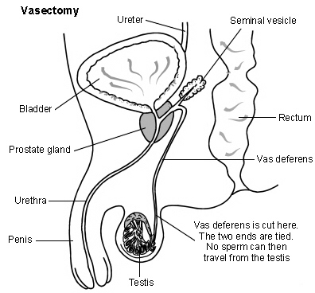

Before operation:
We will be able to provide one stop service for your Vasectomy. On the day of operation, you do not need to fast as this procedure is done under Local Anesthetic. You are expected to read and understand the whole procedure including benefits, side effects and failure rates. You will be asked to sign a consent form.

How is it done?
We use a technique called ‘No Scalpel Technique’. It is done under local anesthetic such as Lignocaine like you may have had at the Dentist. We use a sharp forceps to approach the Vas through scrotal skin. This procedure takes up to 30 minutes. Most of the time, no stitches used.

After operation:
There is usually some discomfort and bruising for a few days afterwards. This usually goes away quickly. Wearing tight-fitting underpants day and night for a week or so after the operation can help the discomfort. It is also best not to do heavy work, exercise or lifting for a week or so after the operation.

Are there any risks involved with this operation?
Most men do not see any side effects or complications after this operation. But a small number of men see few side effects.

It is common to have some bruise in the scrotal skin, which would disappear in a week or two. Skin level infection is another known side effect and may require antibiotics in a small number of people. Very rarely persons develop bleeding into the scrotum which may require further attention. Small numbers of persons develop chronic testicular pain after Vasectomy.

How do you know the operation is successful?
Vasectomy does not work immediately. It is at least 25 ejaculations before all the sperm clear in the tube. So you will be advised to continue using contraception. You will be advised to submit two Semen specimens at 16 and 20 weeks. These will be analysed for any motile sperm. A letter of confirmation of no sperm in the semen will be posted to you and also an advice regarding withdrawal of contraception.

A small number of failures are expected with this operation. Immediate failure is around 1 in 200 and long-term failure is 1/4000. So it is essential you must submit your semen for analyses. Failure to do so will put you at risk of not knowing whether you are sterile or not. In those situations, legally you are bound for your inaction. So we strongly advise you to submit one semen sample in the container provided and post it in the envelope supplied to you.

Few more information you may want to know:
Does the operation hurt?
No more than any other minor operation that uses local anaesthetic. The injection of local anaesthetic may sting a bit for a few seconds. It is put in just a small area of skin, so it is nothing to worry about. After this, the operation is usually painless. After the operation, when the local anaesthetic wears off, the top part of the scrotum is normally mildly sore for a few days. Ignore any scare stories that seem to be a favorite joke topic for some men.

What if I change my mind?
Vasectomy is considered permanent. There is an operation to re-unite the two cut ends of the vas deferens. It is a difficult operation and not always successful. It is also not available on the NHS, so you would have to pay for this yourself.

How soon after the operation can I have sex?
You can resume sex as soon as it is comfortable to do so. However, remember you will have to use other methods of contraception (such as condoms) until you provide two semen specimens which are clear of sperm. Some sperm will survive upstream from the cut vas deferens for a few weeks.

I have heard that there is an increase in the risk of prostate cancer after vasectomy. Is this true?
No. A few years ago there was a scare about a possible link. Since then several surveys have been done and have shown that there is no link between vasectomy and an increased risk of any cancer.

Further Questions?
Please see below Website for further information or contact us on 01302 703443,
Email: vasectomyservice@nhs.net

www.nhscommunityservices.co.uk

www.nhs.uk/Video/Pages/Vasectomy.aspx

www.patient.co.uk/health/vasectomy-male-sterilisation

